**COMP 3133 – Full Stack Development – Lab 1**

* ES6 Practice Exercises

**Developer Note:**

* Try to solve the problems without using search engines or stack overflow for the solutions.

**Exercise 1:**

* Using ES6 syntax, write a function that will get the difference between a given number and 13, if the number is greater than 13 return double the absolute difference



Output:

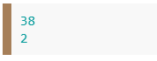

"use strict";

function difference(*number*) {

    if (number <= 13) return 13 - number;

    else return (number - 13) * 2;

}

console.log(difference(32));

console.log(difference(11));

**Exercise 2:**

* Rewrite the following code block using ES6 syntax, *ie. const, let, arrow function, template literals and for..of*

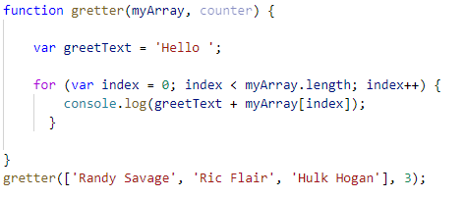

"use strict";

function greeter(*myArray*)

 {

    let greetText='Hello';

    for (let index in myArray) {

  console.log(`${greetText} ${myArray[index]}`);

}

 }

greeter(['Randy Savahe','Ric Flai','Hulk Hogan']);

**Exercise 3:**

* Using **array.proto.map** create function to use the capitalize method in Exercise 2 to upper case the first character of each Color in the following array..

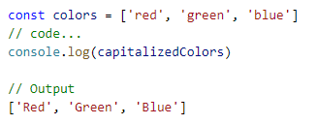

***Array.proto.map Reference***  
 <https://developer.mozilla.org/en-US/docs/Web/JavaScript/Reference/Global_Objects/Array/map>

"use strict";

const colors=['red','green','blue']

const capitalizedColors=colors.map(*x*=>x.charAt(0).toUpperCase()+x.slice(1));

console.log(capitalizedColors);

**Exercise 4:**

* Using **array.proto.filter** create a function that will filter out all the values of the array that are less than twenty.

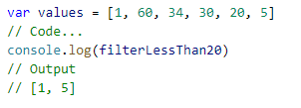  
  
 ***Array.proto.filter Reference***  
 <https://developer.mozilla.org/en-US/docs/Web/JavaScript/Reference/Global_Objects/Array/filter>

"use strict";

var values=[1,60,34,30,20,5]

const filterlessthan20=values.filter(*values*=>values<20);

console.log(filterlessthan20);

**Challenge:**

* Using **array.proto.reduce** create calculate the sum and product of a given array.

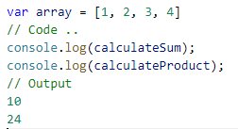

***Array.proto.reduce Reference***

<https://developer.mozilla.org/en-US/docs/Web/JavaScript/Reference/Global_Objects/Array/Reduce>

"use strict";

let array=[1,2,3,4];

const add = (*a*, *b*) =>  a + b

const calculateSum = array.reduce(add)

const product = (*a*, *b*) =>  a * b

const calculateProduct = array.reduce(product)

console.log(calculateSum);

console.log(calculateProduct);